**Results**

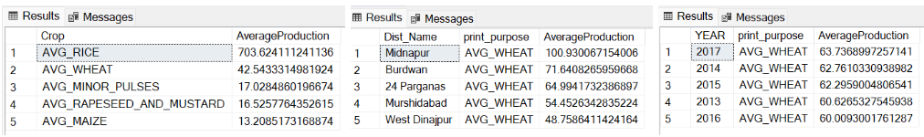**Top 5 crops, districts & years by Average Production**

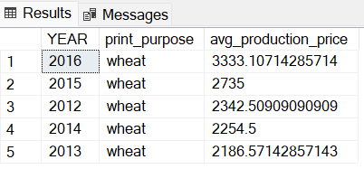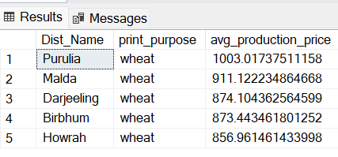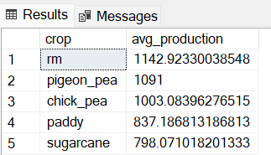**Top 5 crops, districts & years by Average harvest prices**